The fashion sector is well-known for its capacity to establish trends that have the ability to influence society and the purchasing behaviors of a broad range of consumers. However, the influence that regular customers have on the sector is sometimes overlooked. In general, clothing has become more disposable, more of a commodity than something to treasure due to the surprisingly quick rate at which it is now made, worn, and thrown away, and consumers have been trained to expect a steady supply of new goods which creates pollution and landfill. There are so many ways to make sustainable fashion by using the concept frugal innovation.

Before we discuss those methods of frugal innovation, first understand what is fast fashion and how it affects the environment?

**Fast fashion-**

Fast fashion is the term used to describe inexpensive, fashionable apparel that is always being replaced with new collections and flows quickly from design to retail outlets to follow trends.



1

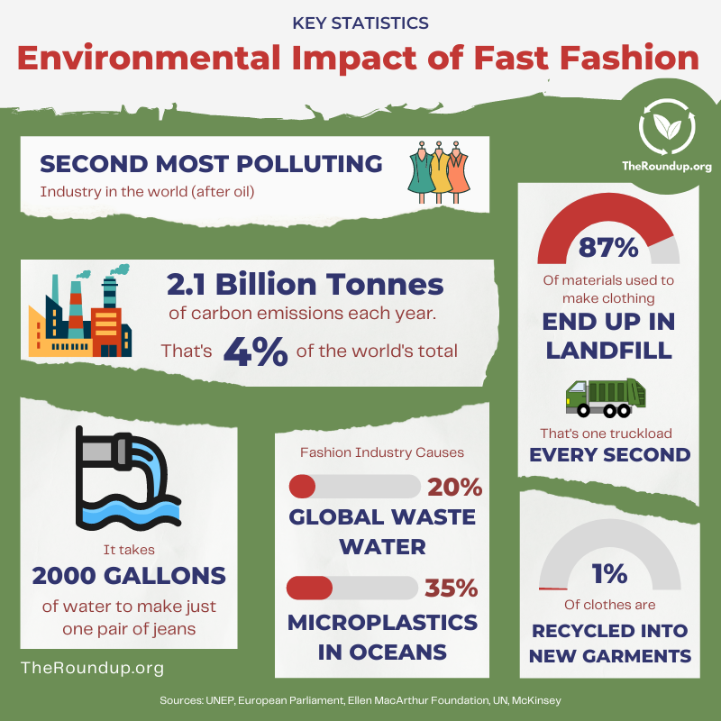

2

There are some tips for quitting fast fashion shown below. By using those tips in our daily life, we can quit fast fashion.

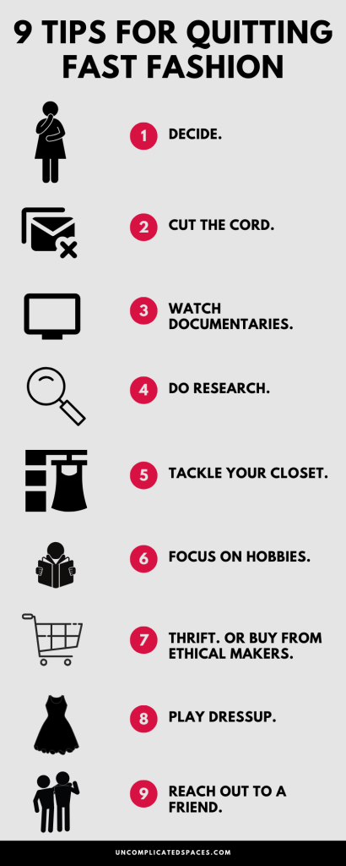

3

4



**Frugal Innovation-**

“It is an ability to do more with less by creating more business and social value while minimizing the use of resources such as energy, capital and time”.

Frugal innovation is developed in severe resource constraints; it involves good quality and reasonably priced products or services even for the customers with modest lifestyles.

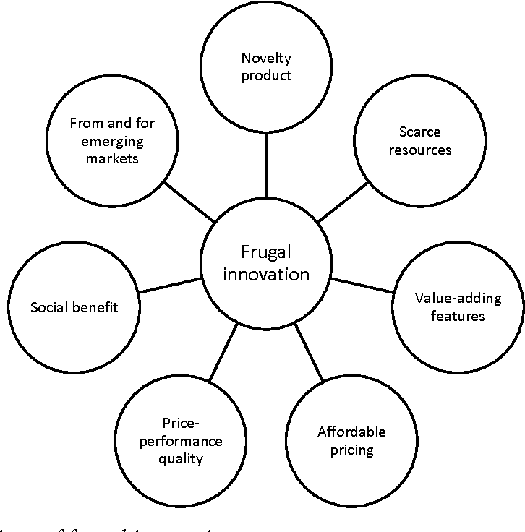

5

Frugal innovations are “good-enough, affordable products that meet the needs of resource-constrained consumers”. Frugal innovation’s focus on context, affordability, and renewability means it could potentially lead to social sustainability. There are some principles of frugal innovation which are discussed below.

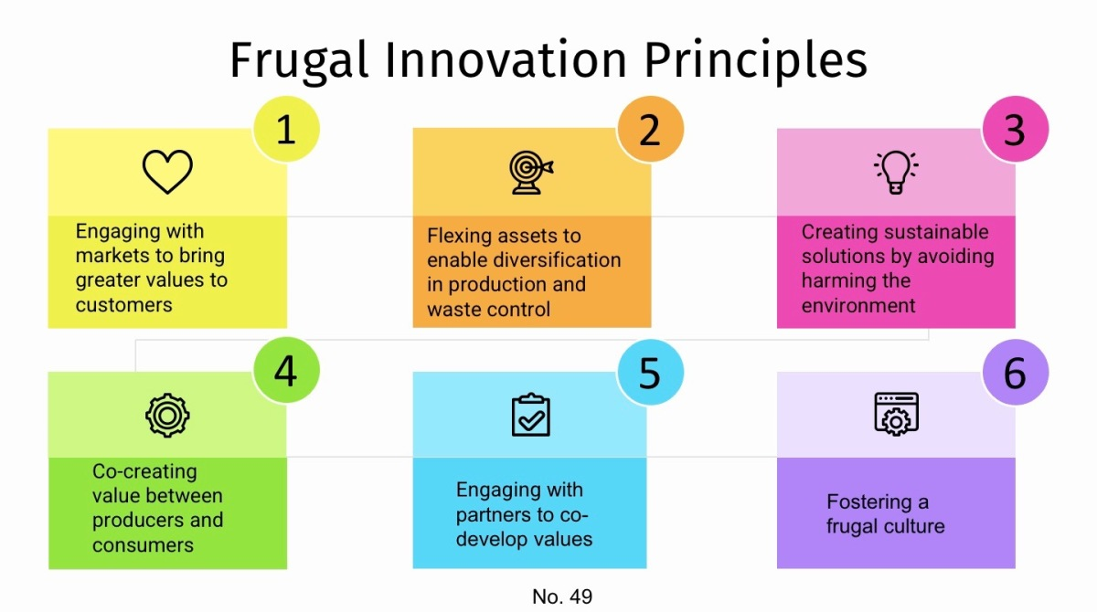

6

**Design concepts which can lead to frugal innovation in apparel designing-**

7

1. 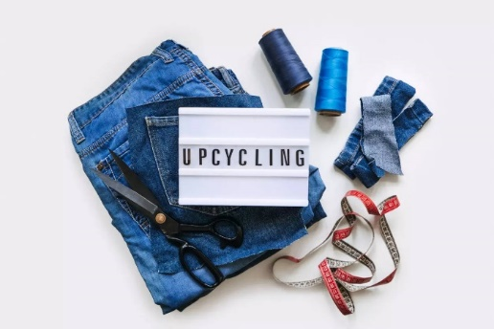**Upcycling-** Upcycling is the practice of creating new, wearable, fashionable products out of used or discarded clothing and materials. It is a sustainable practice used in the fashion industry with the goals of minimizing the negative effects of clothes manufacture on the environment, waste, and resource conservation.

8

10

9

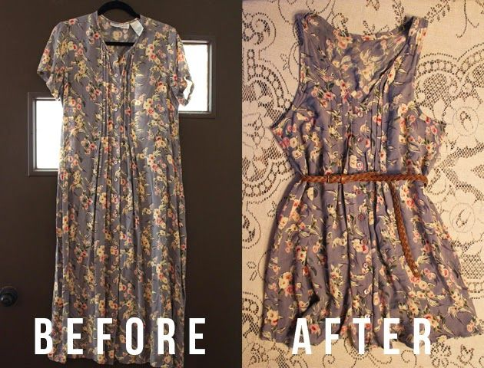

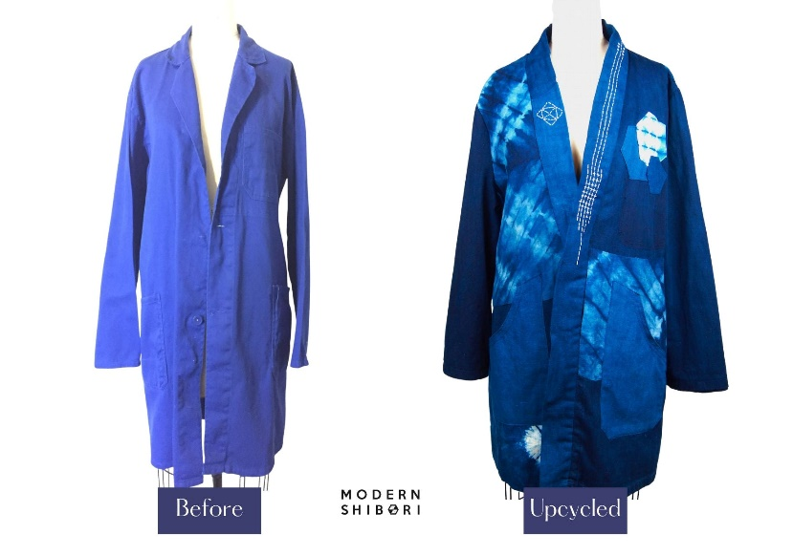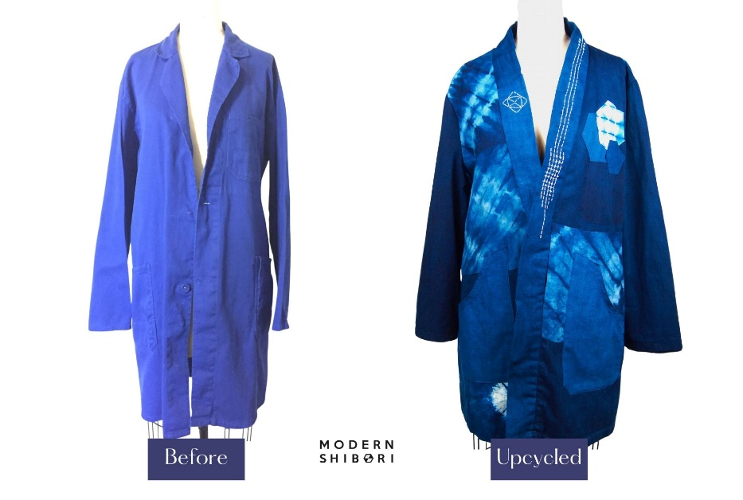

11

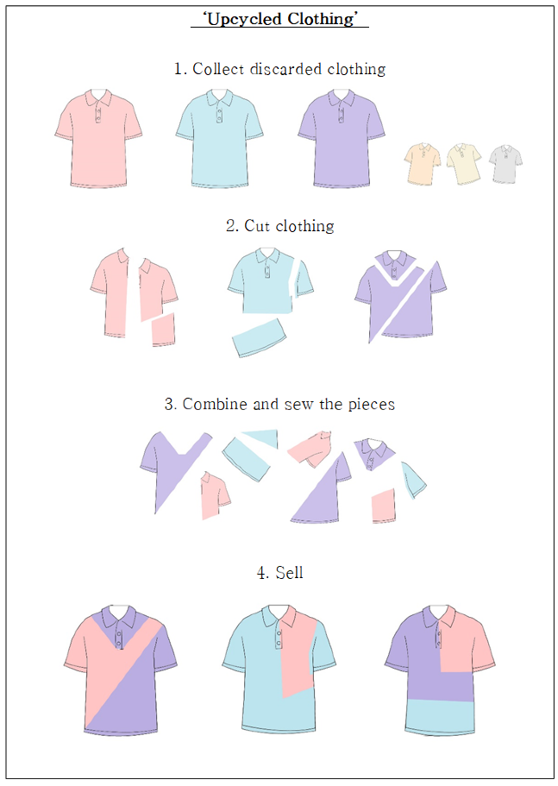

12

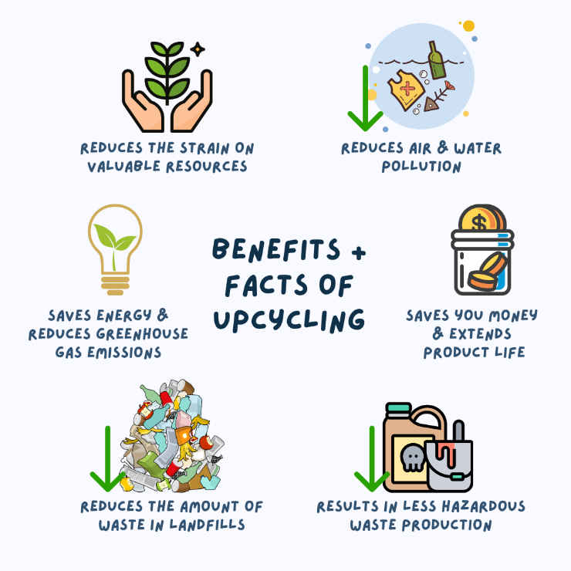

1. **Recycling-** Recycling is the process of converting waste resources into new materials and items.

13

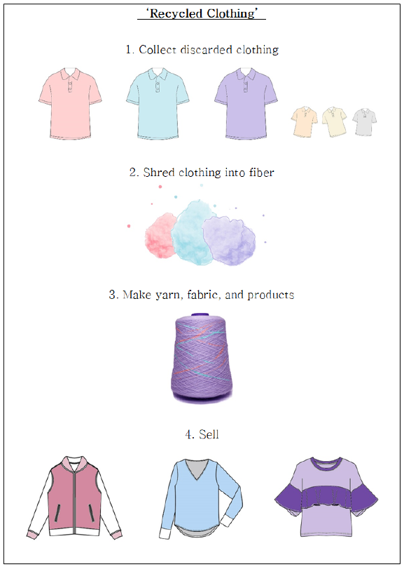

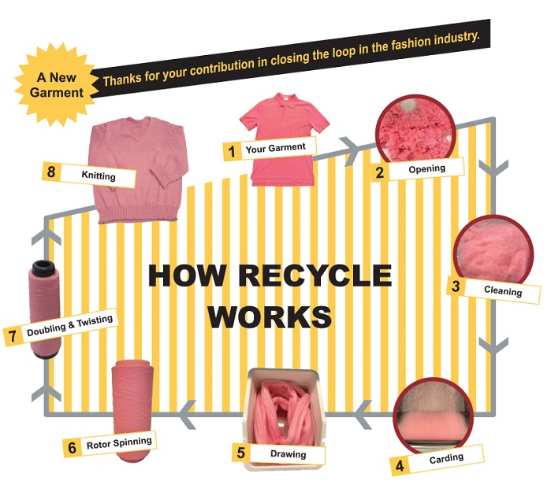

14

15

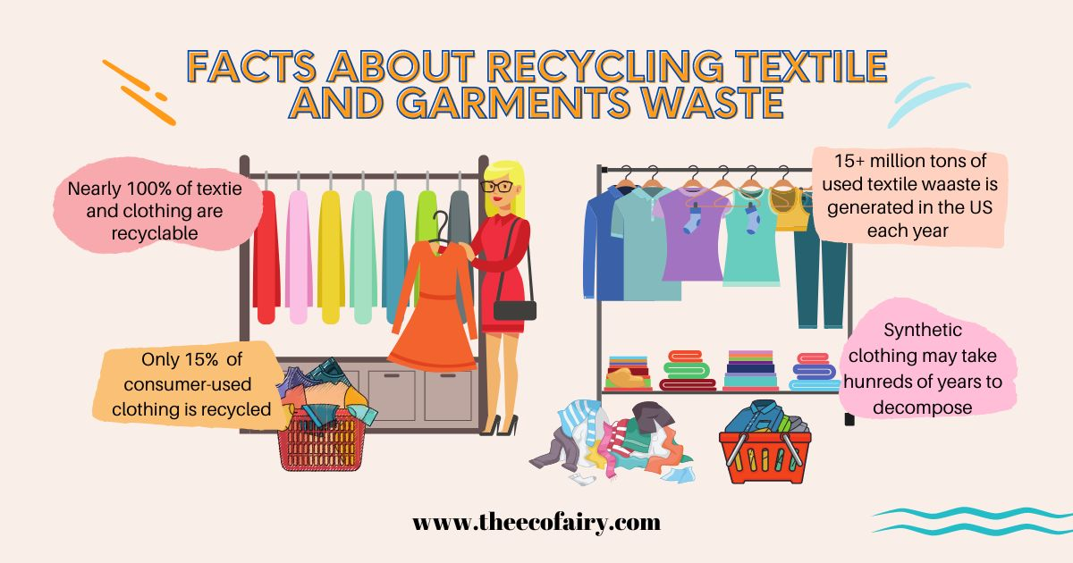

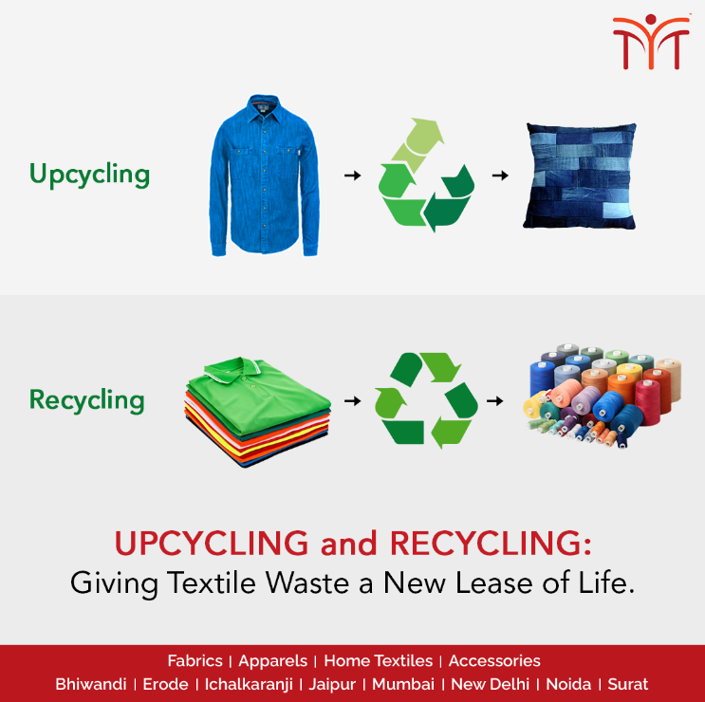

16

1. **Modular design -**

Modular clothing refers to garments with removable or adaptable pieces that can be readily removed, switched out, or reconstructed to create alternative designs, lengths, or overall looks in response to changing fashions or needs.

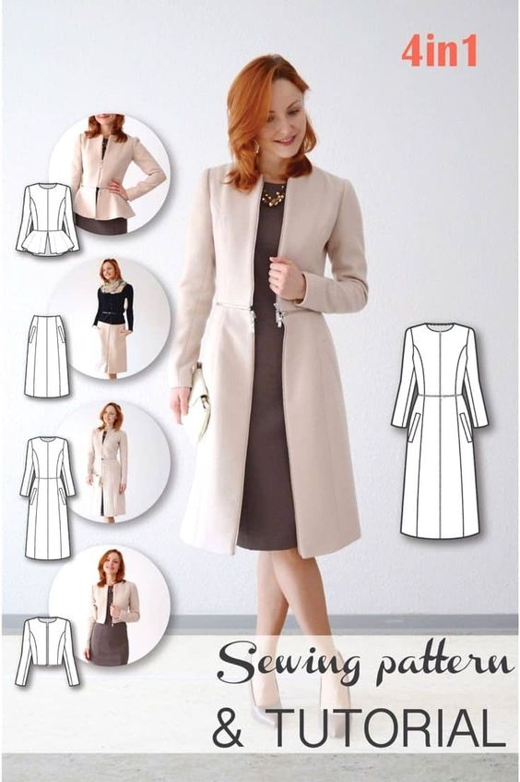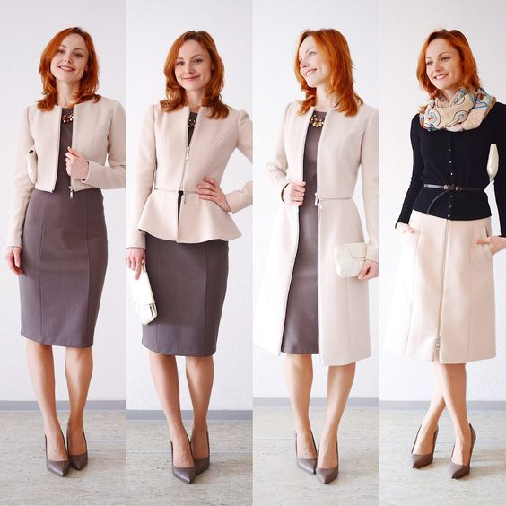

17

1. **Transformable fashion-**

Transformable fashion refers to any clothing item designed to be easily altered, either by the wearer or a specialist service provider.

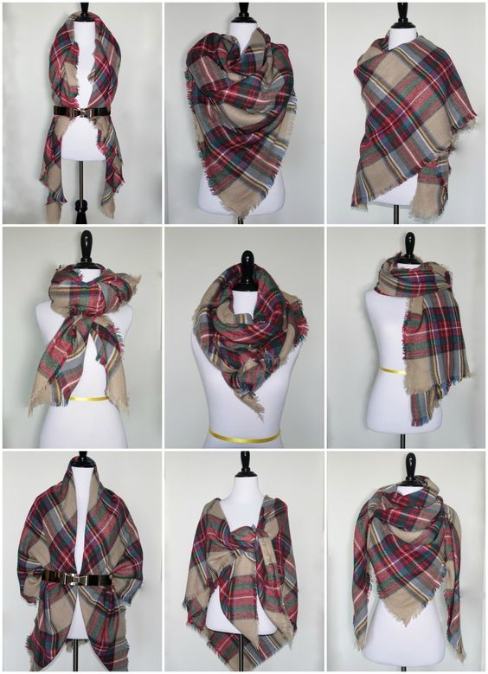

18

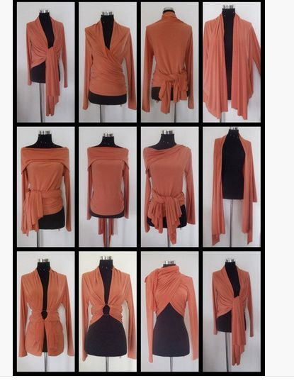

19

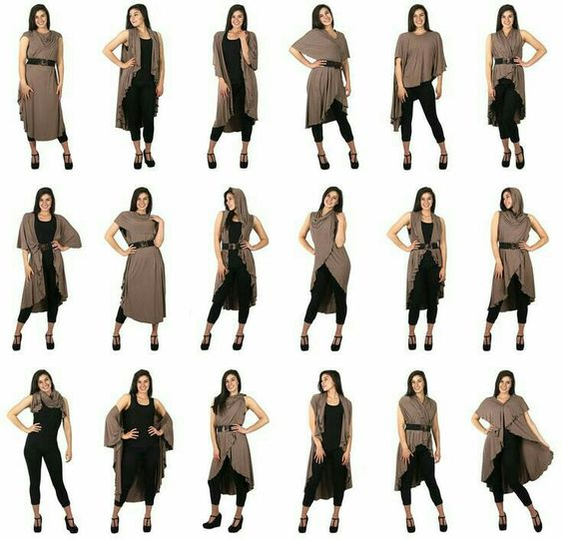

20

1. **Repair-**

Repairs could involve patching tears and snags in the cloth itself or replacing lost or broken parts like rivets, buttons, and zippers.

Repairing can be done by using various techniques-

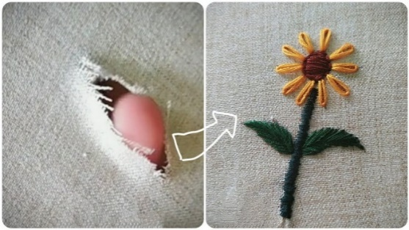

Visible mending

21

22

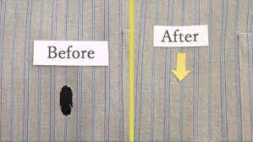

Invisible mending

1. **Minimalism-**

The minimalist approach to clothing entails selecting classic, high-quality garments that are always in trend and having a small wardrobe.

**Ways to Create a Minimalist Wardrobe and Closet**

* **Wear fewer colors**
* **Embrace the idea of one**
* **Donate, sell, recycle, discard**
* **Impose an arbitrary moratorium on shopping**
* **Set a monthly spending limit**
* **Purchase quality over quantity**
* **Avoid the sale racks**

Here, some images shown below to take the idea to create the minimalist wardrobe.

23

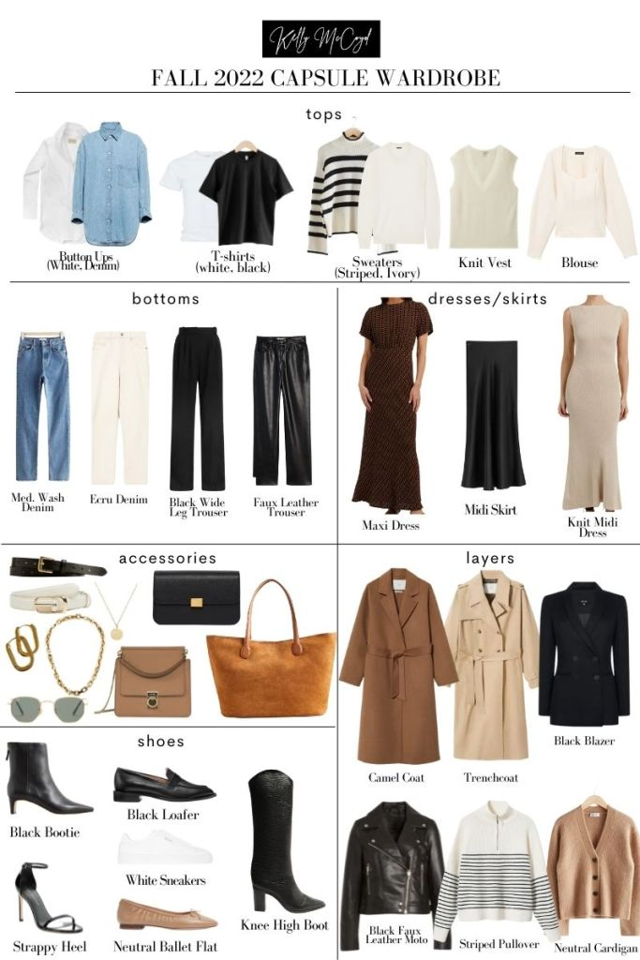

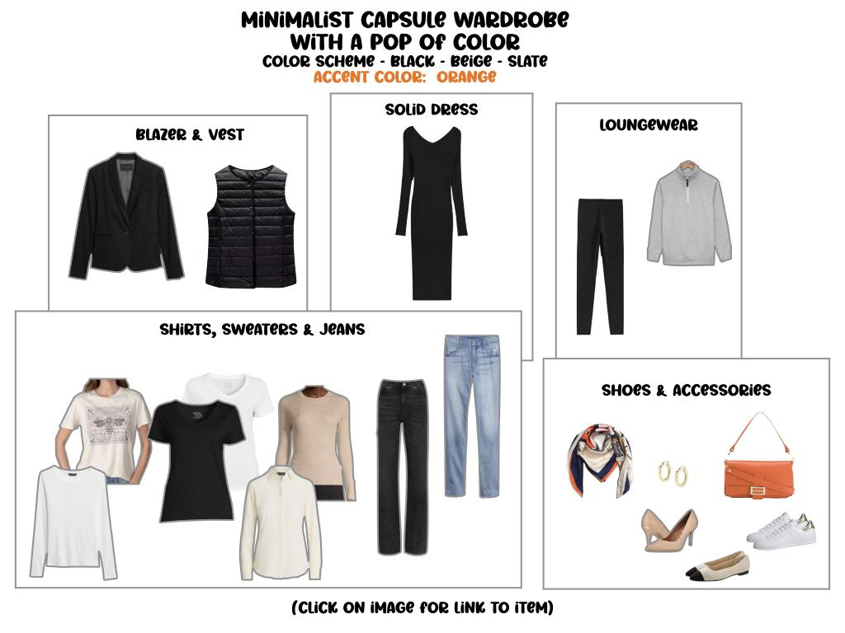

24

25

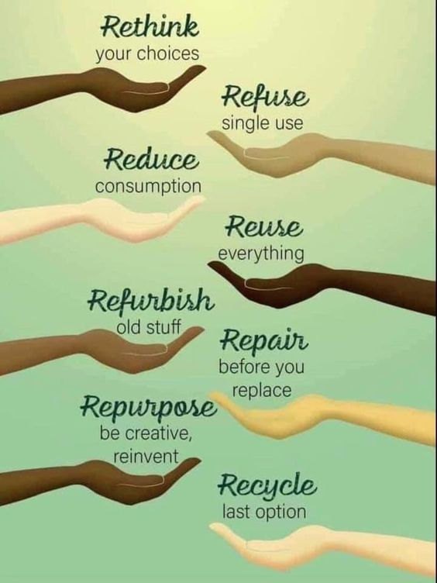

26

